Butikkopca
  - Cart Update fixes

Requirement:
Input price field was working on Desktop but not on Mobile screen only for Flatsome theme.

Fixed:
There were two input fields to update the price of each product on the cart page. One input field was extra and the other one was for the update purpose. (Screenshot attached of both of them)
Extra Input Field:
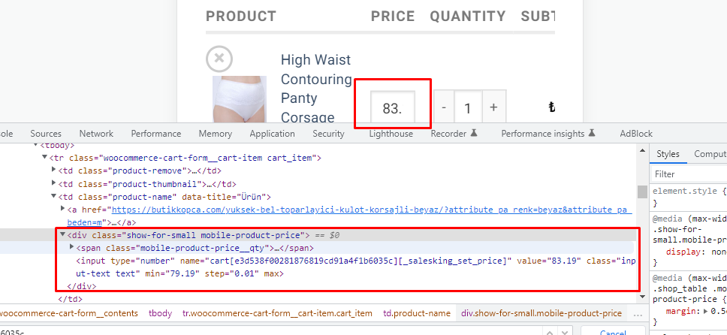
Functional Input Price Field: 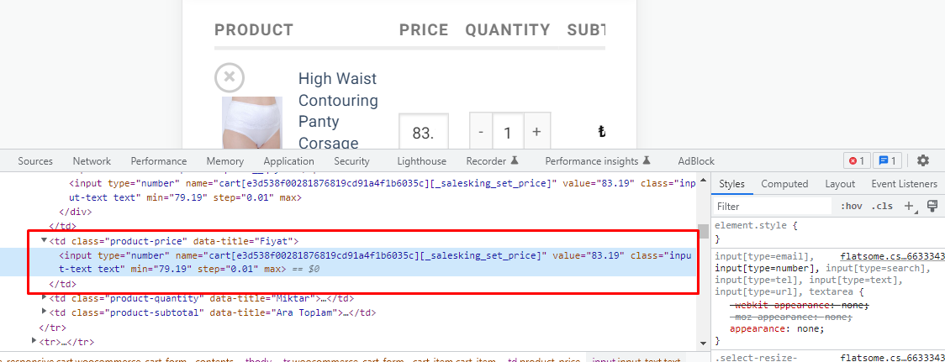

The Problem:
In Flatsome theme’s stylesheet, there was some CSS to hide the functional Price input field and display the extra field (which was not working).

Solution:
We have edited that style sheet of the Flatsome theme so it will display the Functional Price Input field and hide the extra one. (Screenshot attached of that CSS) 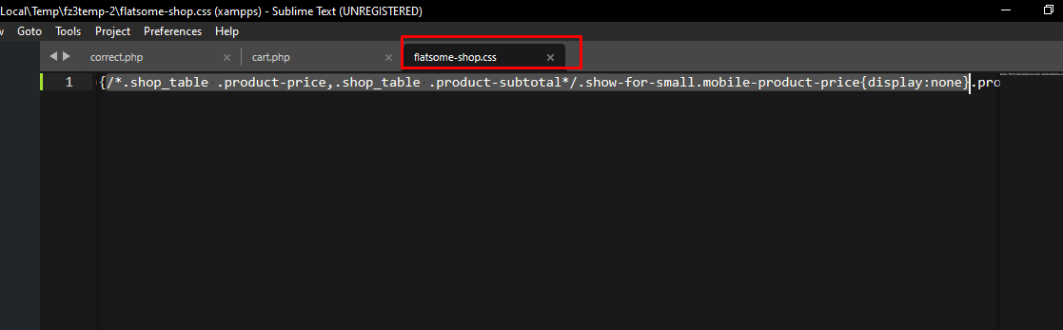
The selected classes in the /* */ were previous. We deactivated those html classes and added new classes (.show-for-small.mobile-product-price).

